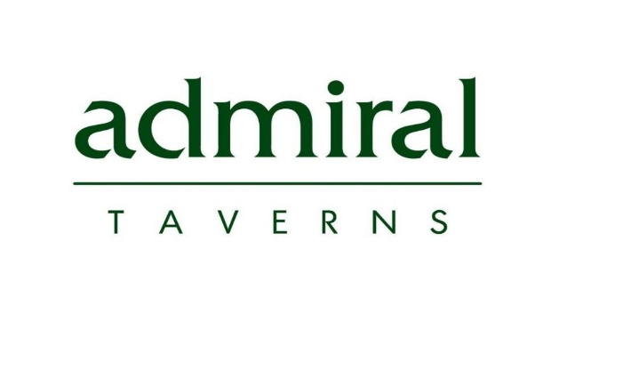
Admiral Taverns Letting Pack

BDM | Becky Whitlock-Torr
Pub | Valentine Inn Llanddulas P01685
Postcode | LL22 8ES
P&L Approved | No
To Let Board Required | Yes
Available From | Now

Facilities Please highlight Yes or No
Beer Garden | Yes
Parking | No
Letting Rooms | No
Play Area | No
Sports Teams | No
Kitchen | Yes
Prep Area | Yes
Live Music | Yes
3+ Bedrooms | Yes
Cask Ale | Yes
Function Room | No
Open Fire | Yes
Sky Sports/ BT Sports | No
WIFI | Yes
Description (Describe type of building, location, demographics and surrounding area, pub layout and surroundings)
The Valentine, steeped in local history, is a medium sized end of terraced, nestled in the heart of Llanddulas, a semi-rural seaside village in Conwy county borough, Wales, midway between Old Colwyn and Abergele. Next to the North Wales Expressway in the community of Llanddulas and Rhyd-y-Foel - this is an upmarket village area which has a mass of cottages and houses with an average selling price of £236,960.
The Valentine holds a prominent position in the village, being on the main route to Gwrych Castle, home of “I’m a celebrity get me out of here” for the past two years and opposite St Cynbryd's Church.
Surrounded by high quality static caravan parks, which attract a year round trade that peaks in the summer months, the Valentine also enjoys a solid trade from B&B and Hotels housing visitors to the incredibly popular area.
The Valentine or the “Val” as it is fondly known as by the villagers is probably the best pub in the area and is the epitome of a top quality local on your doorstep.

Pub Layout (Explain what a customer would see on walking through the doors including external areas)
This is a charming, traditional Pub, steeped in a wealth history and full of character.
When visiting, you are welcomed with a really attractive frontage which continues to the inside presenting everything you would enjoy of a small country pub, with open fires in both the lounge and snug with characteristic narrow corridors with featured bric-a-brac, leading out to a beautiful walled garden – which is a prominent attribute and is probably the best presented quality featured beer garden in the area.

Trading Style (Describe how the pub trades at present. If there is a split on wet/food, explain the retail offer)
Currently trading on net figures of 1.5k dry and 4k wet per week 28/72 % ratio.
The bar offers a solid range of standard and premium bands on both draught and back bar, with a particular focus on an extensive spirit range.
The food offer is a delightful menu of grazing plates, gourmet sandwiches and popular bar snacks, all freshly prepared. There is also a clever chip bar menu with a range of different toppings and accompaniments.
The food here is very popular and bookings are a must in advance, with a waiting list.

Trading Style

Private Accommodation (include if there are any letting rooms)
Kitchen dinner which extends out to balcony area
3 bedrooms
Lounge
Bathroom with WC

BDM Vision
Include plans for Capex
Financials (Breakdown)
Security Deposit: £5,000
Stock: £4,000
Working Capital: £1,000
Rent £24,000
F&F: (date of last valuation & amount) TBA
Training Fee: £325 +VAT (BSA)
Total Upfront Costs: £10,000

BDM Vision

PHOTOS - Min of 5 required (inc. Capex where required – all photos to be taken (“LANDSCAPE”)
Recruitment Vision (What is the criteria of the licensee? e.g. would suit a first time licensee, TAW, experienced operator, 5 year let)
This needs to be let back to back from the current 5 year tenancy agreement with a reasonably experienced community led operator, with the ability to market to and retain tourists visiting the area.

Vision (Your vision for the retail offer)
The offer needs to be maintained exactly as it is described as above – a solid range of standard and premium bands on both draught and back bar, with a particular focus on an extensive spirit range, along with a food offering hosting a menu of grazing plates, gourmet sandwiches and popular bar snacks, all freshly prepared. This offering with the continuation of the well-established pub quiz and immaculate standards, will ensure future success.

Property (Has the pub had Capex or are you planning on any inc property repairs)
Probably going to look at installing 3 phase to the kitchen under RTT.

Three Unique Selling Points

- Well established business - the best pub for miles
- Character and history
- Probably the best beer garden in the area

Additional Information (Any additional information such as opening times, website links)
This really is the best pub in the vicinity, with a well-established trade built up and developed continuously over the past 10 years, by superb operators.
Monday CLOSED
Tuesday 3 pm till 11.00 pm
Wednesday 3 pm till 11.30 pm
Thursday 3 pm till 11.30 pm
Friday 3 pm till 11.30 pm
Saturday 1 pm till 11.30 pm
Sunday 1 pm till 10.00 pm
Food served Tuesday to Saturday 3 pm till 8 pm
KITCHEN CLOSED SUNDAY & MONDAYS
Pub | Valentine Inn | Wales (valentine-inn.co.uk)

Monday CLOSED
Tuesday 3 pm till 11.00 pm
Wednesday 3 pm till 11.30 pm
Thursday 3 pm till 11.30 pm
Friday 3 pm till 11.30 pm
Saturday 1 pm till 11.30 pm
Sunday 1 pm till 10.00 pm

For BDM and Recruitment Team ONLY. (not to be included within advert)
- Would this pub suit a first time operator? N

- If a food offer is applicable, would you be open
to alternative cuisines here i.e Indian, Chinese, Italian etc. N

- Would a Free of Tie Option be considered here? N

- Are we planning any investment/capex here? N (only RTT)

- What are the current average weekly trading figures? As above

